

AMERICAN INTERNATIONAL UNIVERSITY–BANGLADESH (AIUB)
Department of Computer Science
Faculty of Science & Technology (FST)
Fall 2024-25
Section: H, Group: 01

PROJECT TITLE

Virtual Classroom Platform: An Interactive, Accessible, and Engaging Online Learning Environment

Supervised By TONNY SHEKHA KAR

Submitted By

Group Members

SN | Name | ID
1 | AFNAN BIN ISLAM NAHIN | 22-49350-3
2 | AMAN ULLAH | 22-49345-3
3 | HRITTIK BHATTACHARJEE | 21-44650-1
4 | MD. HACHIBUR RAHMAN | 22-46426-1
5 | WALID BIN KHALED | 22-46101-1

Work Breakdown Structure

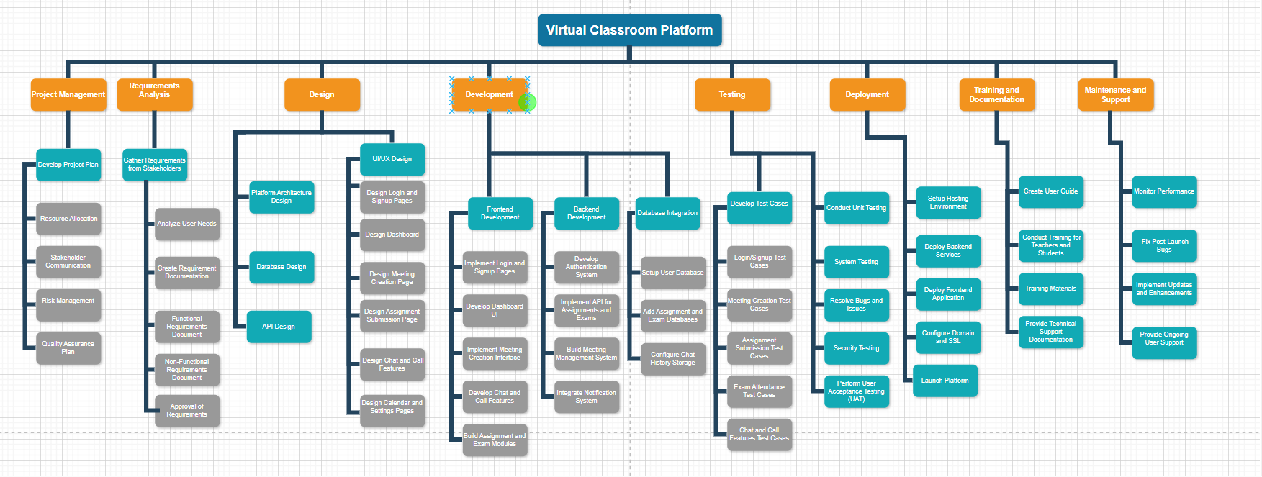

Gantt Chart

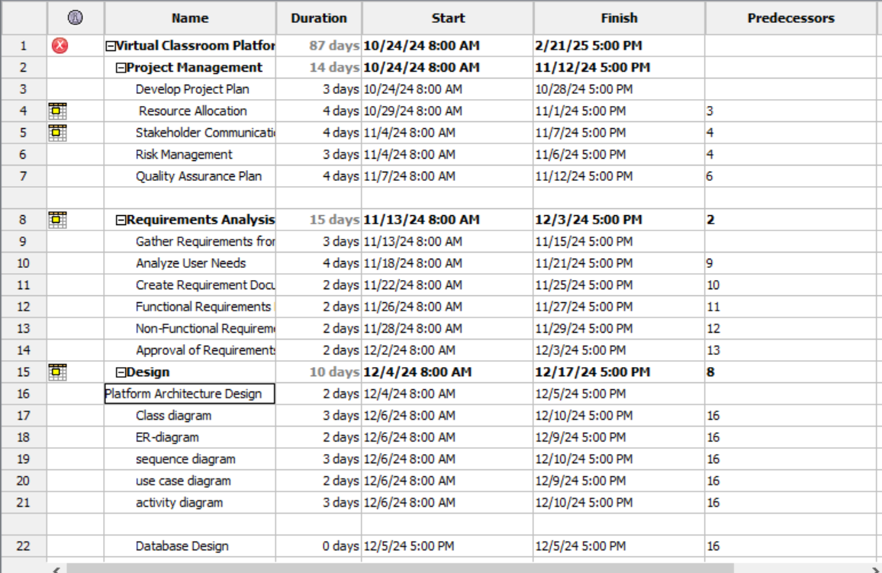
Fig:1

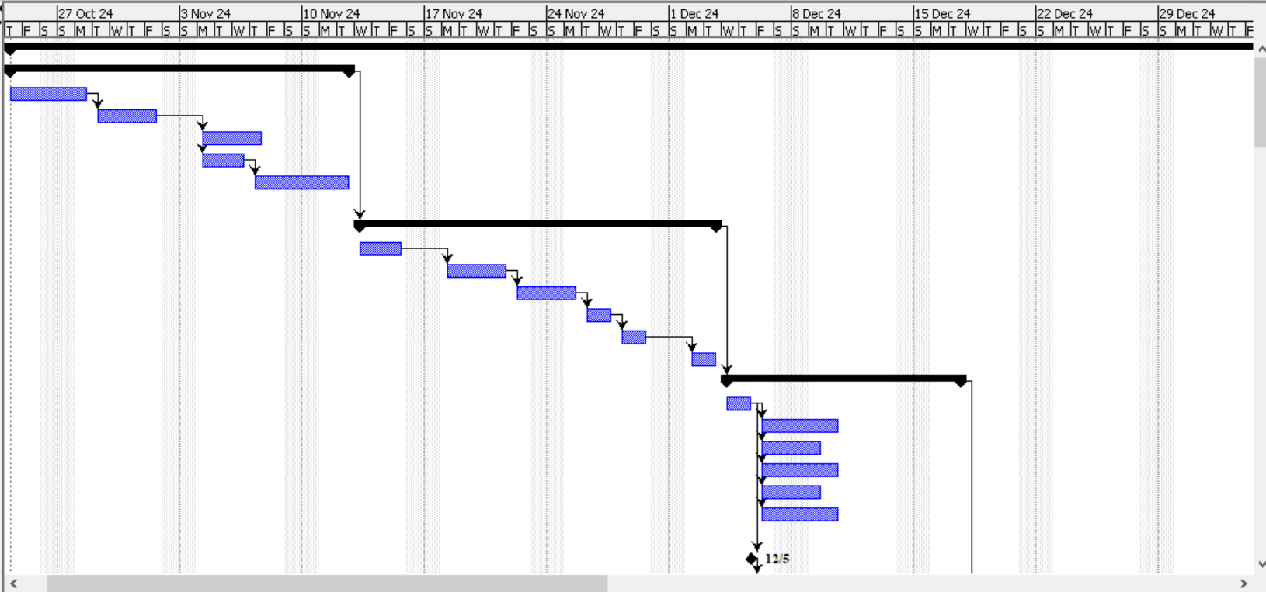
(this timeline chart is from fig-1 line(1-22))

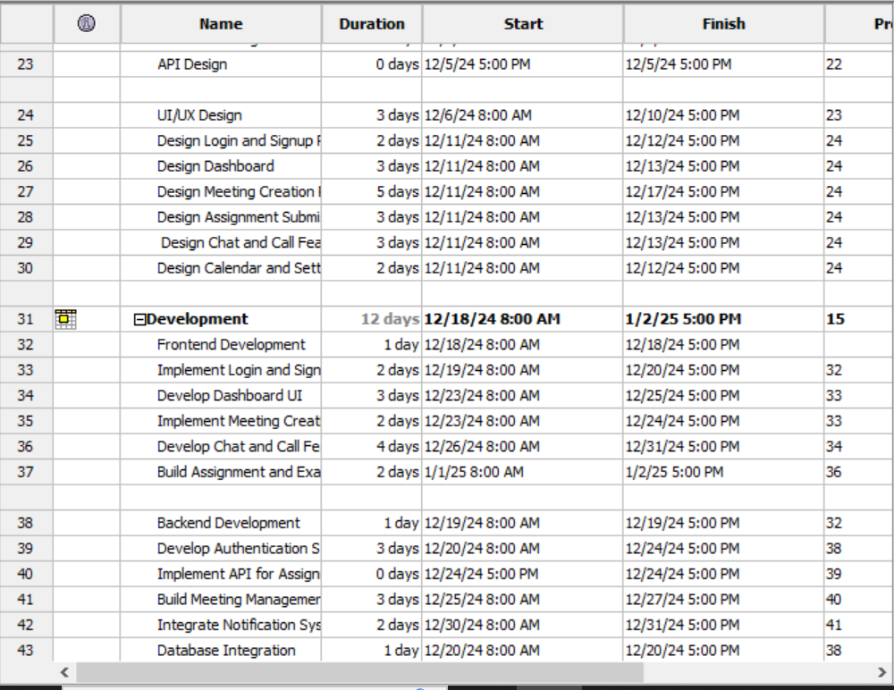
Fig:2

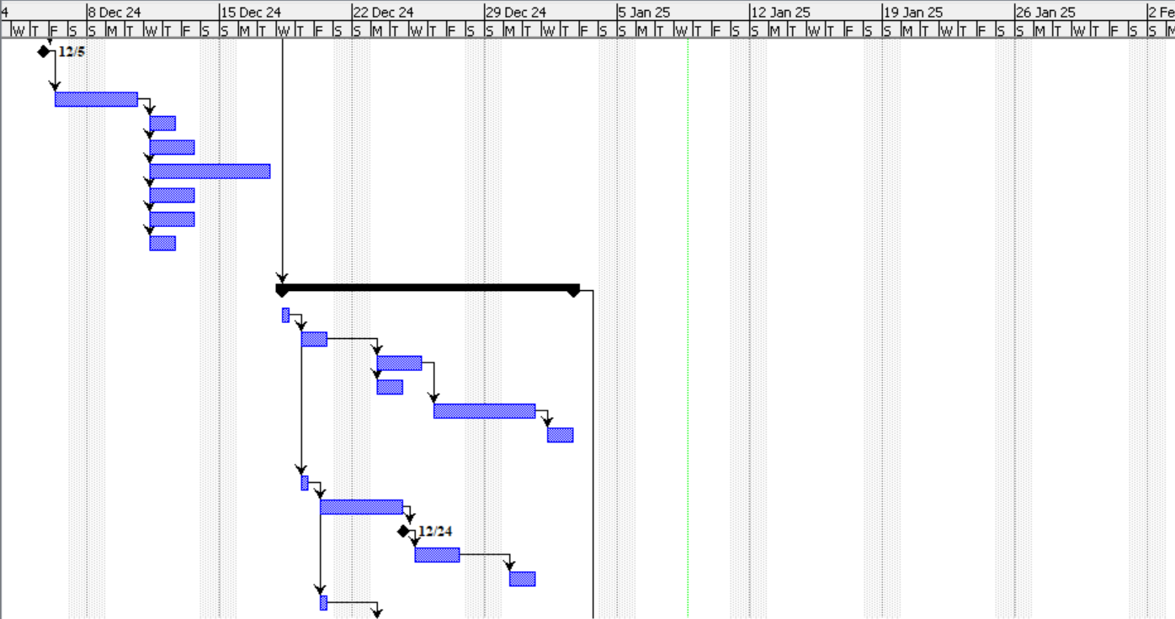
(this timeline chart is from fig-2 line(23-43))

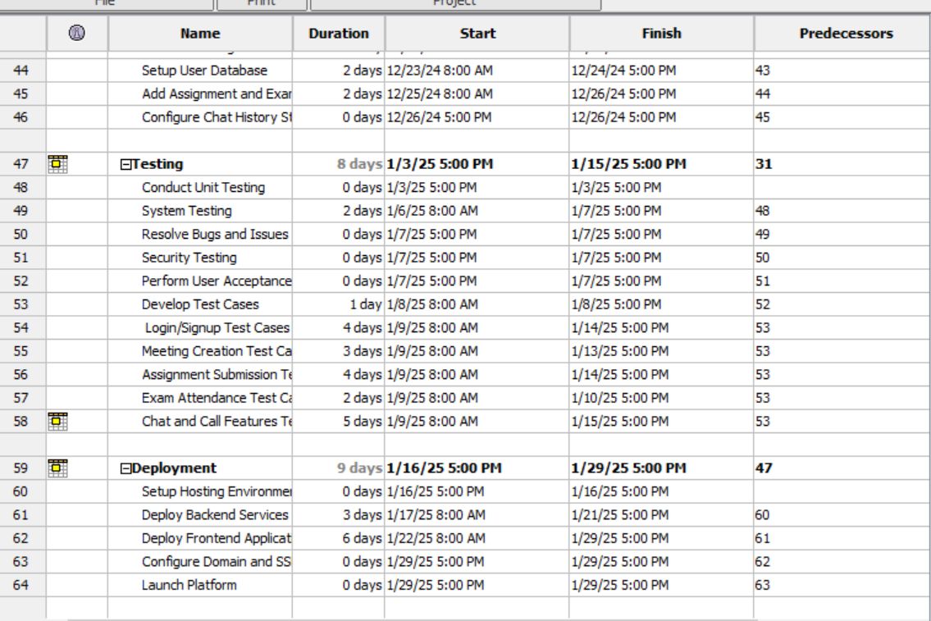
Fig:3

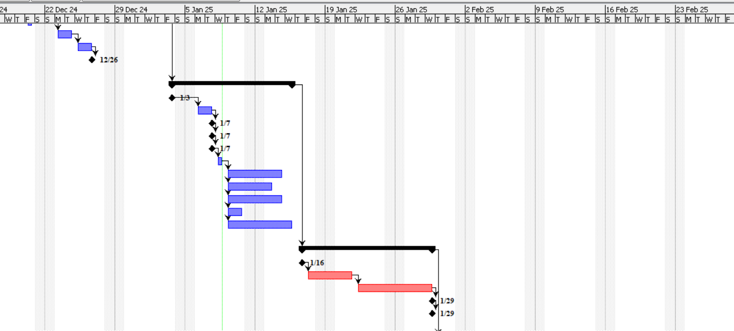
(this timeline chart is from fig-3 line(44-64))

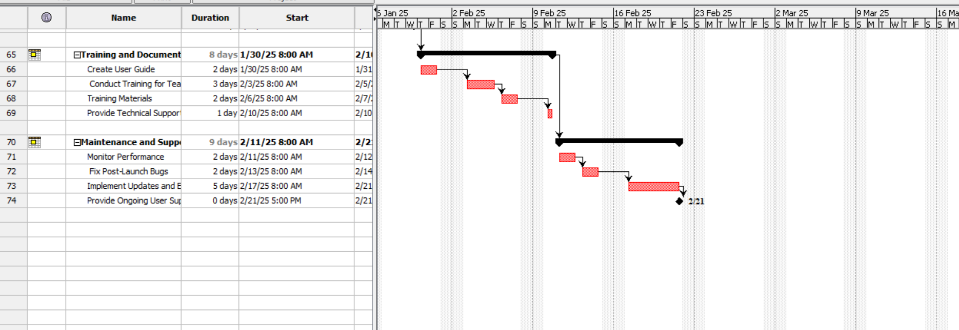
(this timeline chart is from line(65-74))

